Fall 2024, EECE 549
Introduction
In this project, a model of the BLDC motor drive system is implemented, the system parameters are:
$$v_{dc}=45V, r_{s}=0.25Ω, 8 poles, L_{ss}=0.375 mH,$$
$$λ_{m}^{'}=21.5 mV⋅s, J_{rot}=0.22e-3 {kg⋅m}^{2}, T_{fric}=0.12 N⋅m$$
Part 1
The motor is assumed to operate from a three-phase 180-degree VSI using Hall sensors. Initially, assume that $φ_{v}=0$. The models are as follows:
BLDC motor drive system:
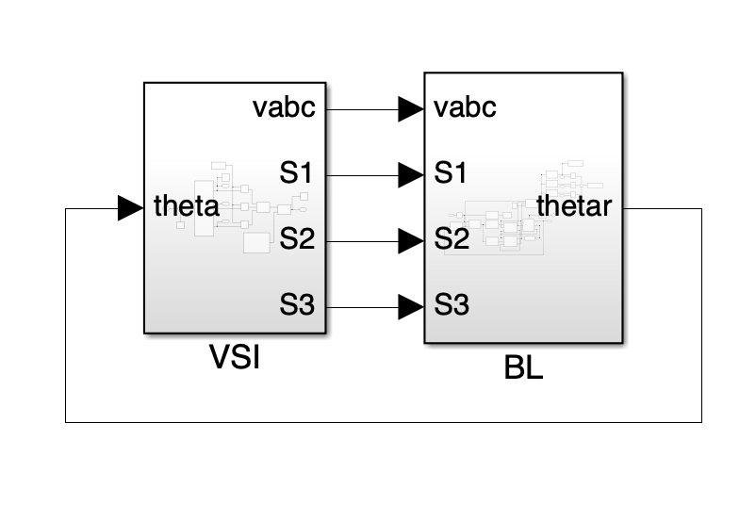
180-degree VSI:
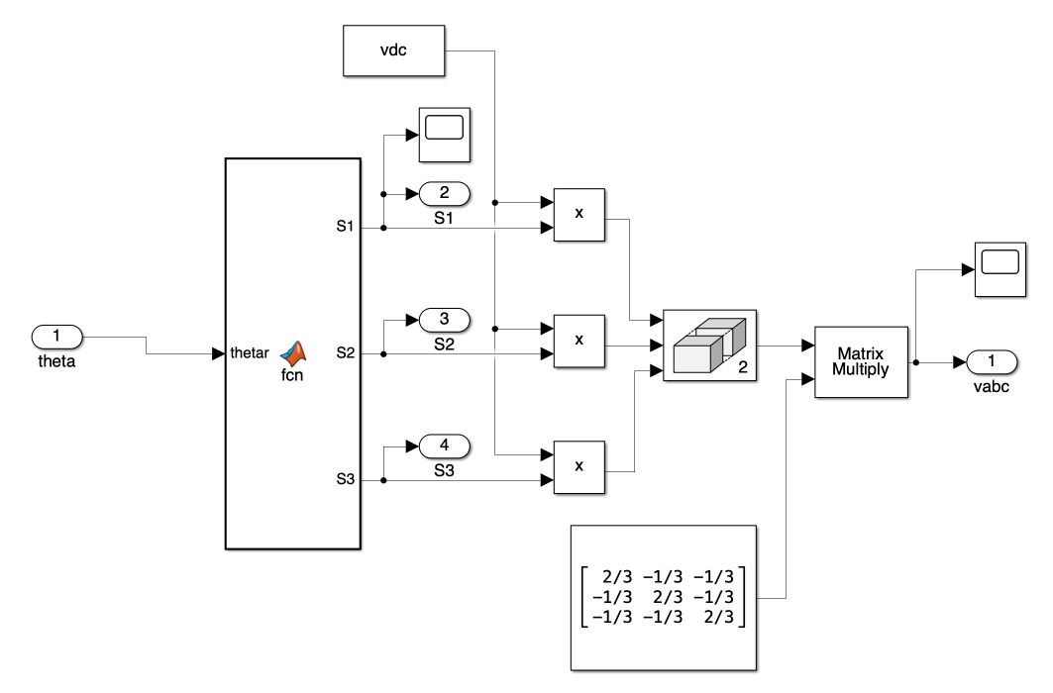

BLDC motor:
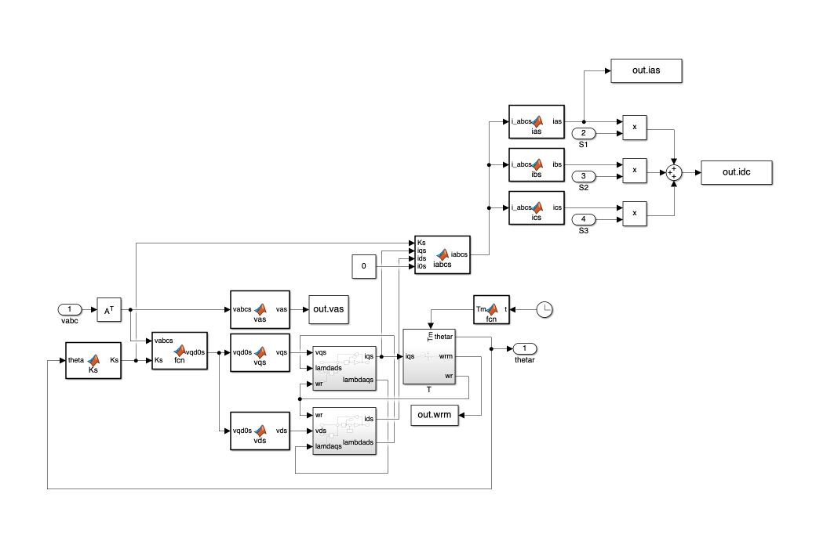
a)
Start the drive system with zero initial conditions. At t = 1.0s, apply a mechanical load torque T_{m} = 1.5 Nm, and continue running the model till t = 2.5 s. The results are as follows:
Comments:
After applying the mechanical torque, the frequency of v_{as} decreases, the amplitude of i_{as} increases, the amplitude of i_{dc} correspondingly increases, the electromagnetic torque increases to balance the load and the rotational speed slightly decreases.

b)
Implement the Average-Value Model and repeat the study in (a). The v_{qs} and v_{ds} are as follows:
$${\overline{v}}_{qs}^{r}=\frac{2}{π}{\overline{v}}_{dc}cos(φ_{v})$$
$${\overline{v}}_{ds}^{r}=-\frac{2}{π}{\overline{v}}_{dc}sin(φ_{v})$$
The model is as follows:
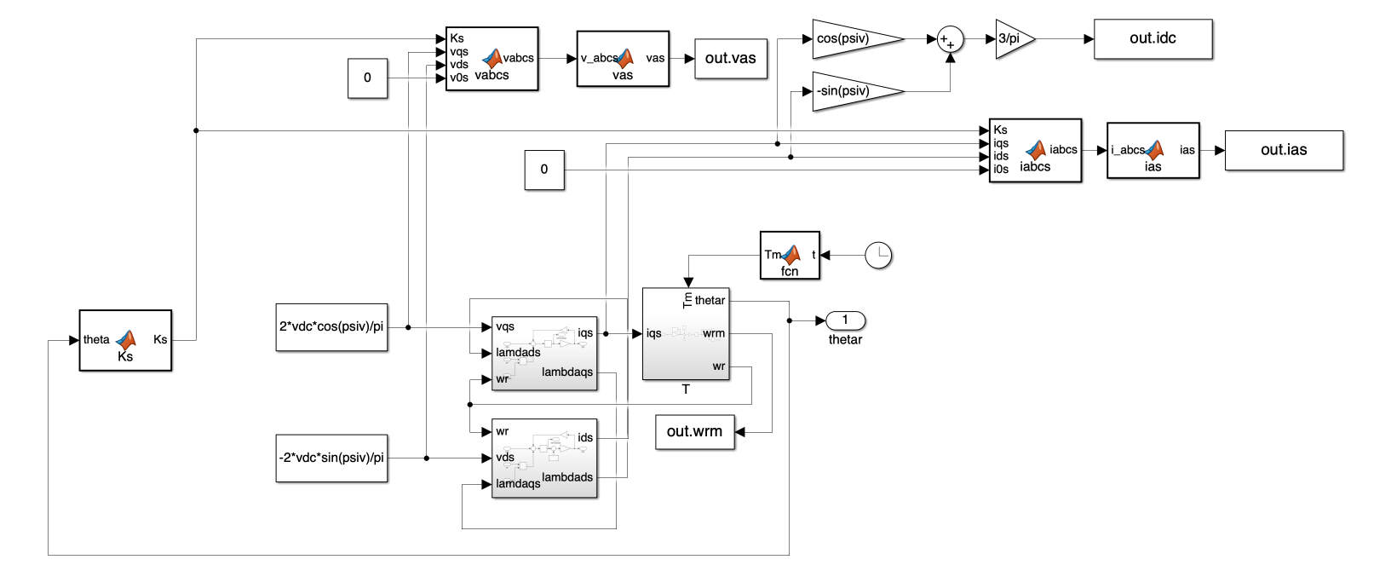
The results are as follows:
Comments:
Compared to the original model, the v_{as} waveform of the average-value model is closer to a sine wave, with variations in amplitude, because a simplified average-value model was implemented instead of a complete average-value model. The i_{as} and i_{dc} of the average-value model are more stable, with smaller amplitudes compared to the original model. The value of T_{e} matches that of the original model but exhibits smaller fluctuations, and the mechanical speed aligns well.

c)
Extract and plot the transfer function $H\left(s\right)=\frac{T_{e}}{v_{dc}}$ corresponding to two operating points as follows:
i) No load
The transfer function is:
$$H\left(s\right)=\frac{219s^{2}+1.46×{10}^{5}s}{s^{3}+1333s^{2}+2.226×{10}^{6}s+9.524×{10}^{7}}$$
ii) Loaded T_{m} = 1.5 Nm
The transfer function is:
$$H\left(s\right)=\frac{219s^{2}+1.46×{10}^{5}s}{s^{3}+1333s^{2}+1.452×{10}^{6}s+1.434×{10}^{8}}$$

The bode diagram of two operating points are as follows:
Comments:
Loading the motor indeed changes the transfer function.
Reason:
Before applying the load, the mechanical equation can be considered as:
$$T_{e}=J\frac{dω_{rm}}{dt}+T_{fric}\left(ω_{rm}\right)$$
After applying the load, the mechanical equation should be considered as:
$$T_{e}=J\frac{dω_{rm}}{dt}+T_{fric}\left(ω_{rm}\right)+T_{m}$$
The system's balance conditions have changed; therefore, the transfer function has changed.

d)
The calculation of the steady-state torque-speed characteristics of the motor is as follows:
$$∵ v_{qs}=r_{s}i_{qs}+ω_{r}L_{d}i_{ds}+ω_{r}λ_{m}^{'}$$
$$v_{ds}=r_{s}i_{ds}-ω_{r}L_{q}i_{qs}$$
$$∴i_{ds}=\frac{ω_{r}L_{q}i_{qs}+v_{ds}}{r_{s}}=\frac{ω_{r}L_{q}}{r_{s}}i_{qs}+\frac{v_{ds}}{r_{s}}$$
$$∴v_{qs}=\left(\frac{r_{s}^{2}+ω_{r}^{2}L_{d}L_{q}}{r_{s}}\right)i_{qs}+\frac{ω_{r}L_{d}v_{ds}}{r_{s}}+ω_{r}λ_{m}^{'}=R_{eq}\left(ω_{r}\right)i_{qs}+\frac{ω_{r}L_{d}v_{ds}}{r_{s}}+k_{v}ω_{r}$$
$$∵T_{e}={\left(\frac{3p}{4}\right)λ_{m}^{'}i_{qs}=k}_{t}i_{qs}$$
$$∴T_{e}=k_{t}\frac{1}{R_{eq}\left(ω_{r}\right)}(v_{qs}-\frac{ω_{r}L_{d}v_{ds}}{r_{s}}-k_{v}ω_{r})$$
In average-value model:
$$v_{qs}=\frac{2v_{dc}}{π}cosφ_{v}$$
$$v_{ds}=-\frac{2v_{dc}}{π}sinφ_{v}$$

$$∴T_{e}=k_{t}\frac{1}{R_{eq}\left(ω_{r}\right)}(\frac{2v_{dc}}{π}cosφ_{v}+\frac{{2ω}_{r}L_{d}v_{dc}sinφ_{v}}{πr_{s}}-k_{v}ω_{r})$$

Use $φ_{v}=-30°$, $φ_{v}=0$, and $φ_{v}=+30°$, and the steady-state torque-speed characteristics of the motor are plotted as follows:

Comments:
After changing the value of $φ_{v}$, the steady-state torque-speed characteristic curve of the motor has changed. The larger the value of $φ_{v}$, the smaller the motor's maximum torque. When $φ_{v}$ is equal to 30 degrees, the motor's electromagnetic torque is maximized at a speed of 0, meaning the electromagnetic torque is largest right when the motor starts. When $φ_{v}$ is 0 or -30 degrees, the motor reaches its maximum electromagnetic torque at negative speeds, and the smaller the value of $φ_{v}$, the higher the speed at which the maximum torque is reached.
When considering positive speeds, if $φ_{v}$ is positive, which corresponds to the advancing angle, the motor's electromagnetic torque at high speeds can be greater than $φ_{v}=0$. However, when $φ_{v}$ is negative, which corresponds to the delaying angle, the torque will quickly reach negative values, meaning the motor will not be able to provide enough electromagnetic torque for driving.

e)
Verify that the detailed and average models predict the same torque-speed characteristics by plotting several points from the dynamic models on top of the analytically derived curves.
Select the following points:
$$φ_{v}=-30°, T_{m}=0: ω_{r}=565.6164 r/s, T_{e}=0.4683 N⋅m$$
$$φ_{v}=-30°, T_{m}=0: ω_{r}=463.8744 r/s, T_{e}=1.6926 N⋅m$$
$$φ_{v}=0°, T_{m}=0: ω_{r}=1275.6092 r/s, T_{e}=0.2768 N⋅m$$
$$φ_{v}=0°, T_{m}=1.5 N⋅m: ω_{r}=910.5544 r/s, T_{e}=1.5946 N⋅m$$
$$φ_{v}=30°, T_{m}=1.5 N⋅m: ω_{r}=1742.136 r/s, T_{e}=1.5194 N⋅m$$
The results are as follows:
Comments:
The results obtained from the detailed model are relatively close to the torque-speed characteristics curve predicted by the average-value model, but they do not match exactly. This is because the $T_{e}$ and $ω_{r}$ obtained from the detailed model fluctuate, so they only appear near the steady-state speed-torque characteristics curve and are unlikely to match perfectly.

f)
Set the derivative of the electromagnetic torque to zero, then the $φ_{v}$ as a function of speed $ω_{r}$, which always maximizes the torque, can be derived as follows:
$$φ_{v}=\tan^{-1}{(\frac{ω_{r}L_{ss}}{r_{s}})}$$
The resulting steady state torque-speed characteristic is as follows:
Compare it with the characteristics obtained in step d):
Comments:
Since $φ_{v}$can vary dynamically with speed $ω_{r}$, it can achieve the maximum electromagnetic torque at each speed.

Part 2
The motor is assumed to operate from a three-phase 180-degree VSI using Hall sensors. Initially, assume that $φ_{v}=0$.
a)
When implementing the 180-degree VSI, a function is used to determine the values of S_{a}, S_{b}, and S_{c}, with the input of the function being $θ_{r}$. The function can now be modified to decide how to set S_{a}, S_{b}, and S_{c} based on the conditions in the table below:

Active Switch | Rotor Position
Sa=1 | -30 to 90 | 150 to 270
Sb=1 | 90 to 210 | -90 to 30
Sc=1 | 210 to 330 | 30 to 150

When the rotor position reaches different angles, set Sa, Sb, or Sc to 1 accordingly, and set the others to 0. This completes the implementation of the 120-degree VSI.

b)
Implement the Average-Value Model and repeat the study in Part 1 (a). The v_{qs} and v_{ds} are as follows:
$${\overline{v}}_{qs}^{r}=\frac{\sqrt{3}}{π}cos\left(φ_{v}-\frac{π}{6}\right){\overline{v}}_{dc}+\frac{1}{2}[1-\frac{3\sqrt{3}}{2π}cos\left({2φ}_{v}-\frac{π}{3}\right)]ω_{r}λ_{m}^{'}$$
$${\overline{v}}_{ds}^{r}=-\frac{\sqrt{3}}{π}sin\left(φ_{v}-\frac{π}{6}\right){\overline{v}}_{dc}+\frac{3\sqrt{3}}{4π}sin\left({2φ}_{v}-\frac{π}{3}\right)ω_{r}λ_{m}^{'}$$
The model is as follows:
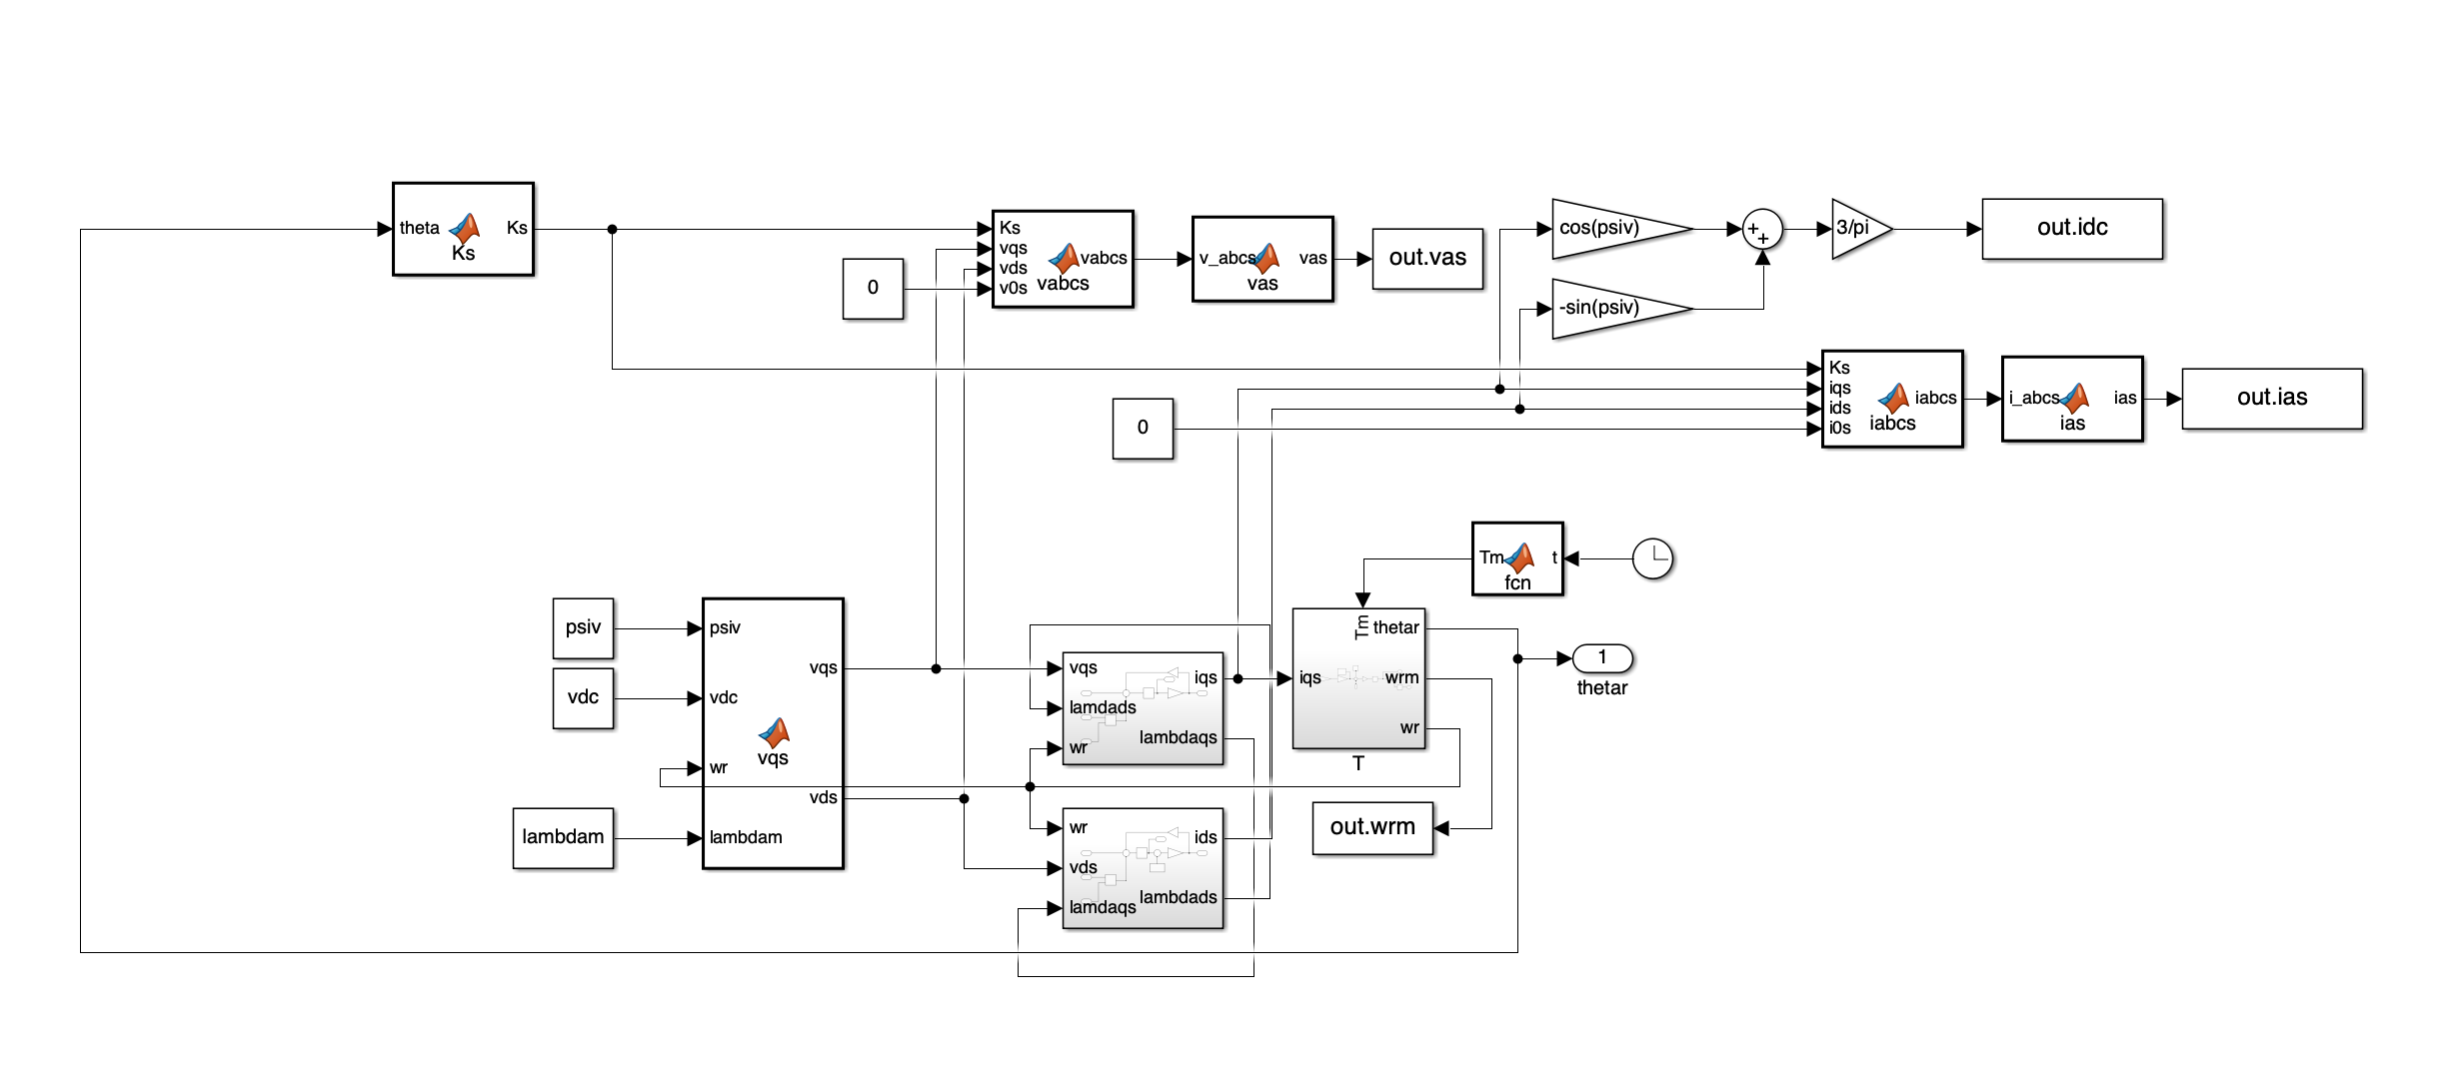

The results are as follows:
Compare the results of 180-degree VSI and 120-degree VSI:
Comments:
The v_{as} obtained from the 120-degree VSI is smoother compared to the 180-degree VSI, but the amplitude of the i_{as} is larger. This is because in the 120-degree VSI, the voltage output of each phase is smoother, so to maintain the required power and torque output, the current amplitude must be larger to compensate for the smaller voltage fluctuations. Both VSI have the same i_{dc} and T_{e}, but the steady-state speed obtained from the 120-degree VSI is lower. This is because in the 120-degree VSI, only two phases provide voltage during each electrical cycle, while in a 180-degree VSI, all three phases provide voltage during each cycle. Therefore, the driving efficiency of the 120-degree VSI is relatively lower, resulting in a smaller output speed of the motor.

c)
Recall:
$$T_{e}=k_{t}\frac{1}{R_{eq}\left(ω_{r}\right)}(v_{qs}-\frac{ω_{r}L_{d}v_{ds}}{r_{s}}-k_{v}ω_{r})$$
$${\overline{v}}_{qs}^{r}=\frac{\sqrt{3}}{π}cos\left(φ_{v}-\frac{π}{6}\right){\overline{v}}_{dc}+\frac{1}{2}[1-\frac{3\sqrt{3}}{2π}cos\left({2φ}_{v}-\frac{π}{3}\right)]ω_{r}λ_{m}^{'}$$
$${\overline{v}}_{ds}^{r}=-\frac{\sqrt{3}}{π}sin\left(φ_{v}-\frac{π}{6}\right){\overline{v}}_{dc}+\frac{3\sqrt{3}}{4π}sin\left({2φ}_{v}-\frac{π}{3}\right)ω_{r}λ_{m}^{'}$$
Use $φ_{v}=-30°$, $φ_{v}=0$, and $φ_{v}=+30°$, and the steady-state torque-speed characteristics of the motor are plotted as follows:
Compare the results with the characteristics obtained by 180-degree VSI:
Comments:
Due to only two phases being conductive in the 120-degree VSI, its driving capacity is weaker. The steady-state torque of the motor at higher speeds is smaller than when using a 180-degree VSI, meaning that the motor finds it more difficult to provide sufficient torque for driving at higher speeds.
d)
Verify that the average models predict the same torque-speed characteristics by plotting several points. The selected points are as follows:
$$φ_{v}=-30°, T_{m}=0: ω_{r}=351.1728 r/s, T_{e}=0.12 N⋅m$$
$$φ_{v}=-30°, T_{m}=0: ω_{r}=247.5820 r/s, T_{e}=1.62 N⋅m$$
$$φ_{v}=0°, T_{m}=0: ω_{r}=883.1540 r/s, T_{e}=0.12 N⋅m$$
$$φ_{v}=30°, T_{m}=0: ω_{r}=1212.2252 r/s, T_{e}=0.12 N⋅m$$
$$φ_{v}=30°, T_{m}=1.5 N⋅m: ω_{r}=845.9648 r/s, T_{e}=1.62 N⋅m$$
Comments:
Since the prediction is made using the average value model, and validation is also performed using the average value model, the selected points perfectly match the prediction curve.

Summary:
The modelling of the brushless DC motor and its driving system is simple, as it can be modelled using limited voltage, flux linkage, and mechanical equations. When modelling the driving system, the switching states are determined based on the rotor position. The rotor position is detected by Hall sensors, and using a 6-step commutation method, the switching states can be determined when the rotor is at different positions. There are some differences between the 180-degree VSI and the 120-degree VSI: the 180-degree VSI is on for 180 degrees of each electrical cycle, while the 120-degree VSI is only on for 120 degrees. This is because the 180-degree VSI has three phases providing voltage at each instant, while the 120-degree VSI only has two phases. Through the calculation of the steady-state torque-speed characteristics curve, I gained a deeper understanding of the effects of the inverter’s advancing and delaying angles. By increasing the advancing angle, the transistors in the inverter are driven earlier, which increases the effective current amplitude, thereby improving the steady-state torque. On the other hand, increasing the delay angle causes a delay in the transistor conduction time, which may result in the motor being unable to provide enough torque for driving. If the control angle is adjusted according to the speed, so that maximum torque is achieved at every speed, it would significantly improve the performance of the brushless motor.
Finally, I would like to give a brief summary of the entire course. I have learned a lot from this course, starting from knowing nothing at the beginning to gradually learning how to use MATLAB and Simulink, as well as acquiring various knowledge about motors. In the first assignment, I learned how to calculate the system stiffness ratio and understood the differences between different solvers. In the second assignment, I learned how to model transformers, which form the basis for subsequent courses. In the third assignment, I discovered that an induction machine is essentially a rotating transformer, and I also learned about Park's transformation, a method that simplifies motor analysis. In the fourth assignment, I modelled a synchronous machine using per-unit (pu) values and realized how efficient the use of per-unit values is in motor analysis. The fifth assignment taught me how to build a drive system for an induction machine, understand inverters that convert DC signals into AC signals, and learn how to build VSI and CSI in Simulink, using these two inverters to control motors with different control methods. In the final assignment, I learned how to control a brushless DC motor. This has been a very interesting course; although the process of building models can be very challenging, the satisfaction of achieving results after success is truly rewarding. Finally, I would like to thank the professor, the TA, and my classmates with whom I discussed the assignments.^_^

